**AmMetLife Takaful Donates RM20,000 Wakalah Zakat to Universiti Malaya in Support of Student Welfare**

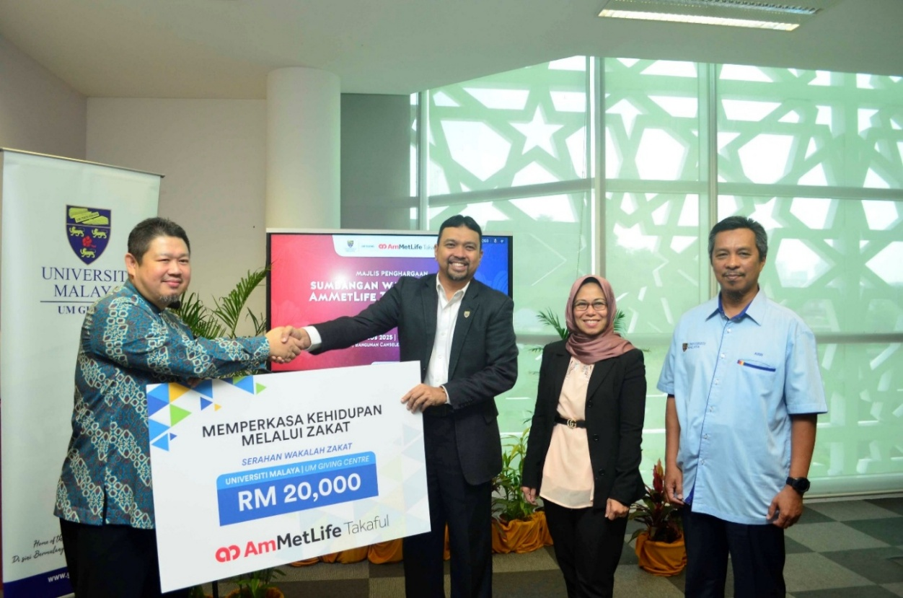

**From Left: Ustaz Salihin Deris (Chairman, Shariah Committee – AmMetLife Takaful), En. Wan Mohd Sofi Wan Mustapha (Bursar, UM), Dr. Azni Zarina Taha (Executive Director, UM Giving Centre), and En. Azizi Che Seman, Academy of Islamic Studies, UM).**

**Kuala Lumpur, 12 August 2025 – AmMetLife Takaful Berhad (AmMetLife Takaful) contributed RM20,000 in wakalah zakat to Universiti Malaya(UM) through the *“Memperkasa Hidup Melalui Zakat”* (Empowering Lives Through Zakat) initiative by the UM Giving Centre.**

The mock cheque presentation ceremony was held at Universiti Malaya and officiated by Ustaz Mohammad Salihin Deris, Chairman of the Shariah Committee of AmMetLife Takaful. Encik Wan Mohd Sofi Wan Mustapha, Bursar of Universiti Malaya, and Dr. Azni Zarina Taha, Executive Director of UM Giving Centre, received the cheque.

**About AmMetLife Takaful**

AmMetLife Takaful is a strategic partnership between AMMB Holdings Berhad (AmBank Group) and MetLife International Holdings, Inc. (MetLife). The strategic partnership combines the international expertise and financial strength of MetLife with the local strength and reach of AmBank Group.

AmMetLife Takaful offers a comprehensive range of takaful solutions distributed by its authorised takaful agents and AmBank branches nationwide. With our passion to provide excellent services, together with a deep and respectful knowledge of Shariah principles and values, we aim to be a customer-centric and modern takaful operator in Malaysia.

For further information on AmMetLife Takaful Berhad, please contact the Corporate Communications Department at [AmMetLife-Communicator@ammetlife.com](mailto:AmMetLife-Communicator@ammetlife.com)